***SOFTWARE REQUIREMENTS SPECIFICATION (SRS)***

***BLOOD BANK SYSTEM***

***Table Of Contents***

***1. Introduction.............................................................................................5***

***1.1 Purpose***

***1.2 Intended audiences***

***1.3 Additional information***

***1.4 Contact information/SRS team members***

***1.5 References***

***2. Overall Description.................................................................................7***

***2.1 Product perspective***

***2.2 Product functions***

***2.3 Data Flow Diagrams***

***2.4 Use Case Diagrams***

***2.5 User classes and characteristics***

***2.6 Operating environment***

***2.7 Design/implementation constraints***

***2.8 Assumptions and dependencies***

***3. External interface Requirements.........................................................14***

***3.1 User interfaces***

***3.2 Hardware interfaces***

***3.3 Software interfaces***

***3.4 Communication protocols and interfaces***

***4. System Features..................................................................................15***

***4.1 Login Interface***

***4.2 Logout***

***4.3 Donor Profile***

***4.4* Blood Stock Management**

**4.5 Report**

***5. Other Non-Functional Requirements..................................................18***

***5.1 Performance requirements***

***5.2 Safety requirements***

***5.3 Security requirements***

***5.4 Software quality attributes***

***5.5 User documentation***

***6. Other Requirements............................................................................20***

***6.1 DEFINITIONS, ACRONYMS, ABBREVIATIONS***

***6.2 To be determined***

***ABSTRACT:***

The aim of this blood bank system is to maintain the efficiency, accuracy and safety of blood donation and several other processes like transfusion. It also helps to maintain a record of blood donors, inventory and history. This leads to better patient outcomes and reduced risks associated with blood transfusions. A blood bank management system project can be a useful way to apply various software development principles and practices. It involves the development of a software system that manages the collection, storage, testing, and distribution of blood and its components. This project can help software engineers gain practical experience in requirements gathering, design, implementation, testing, and deployment of a software system. It can also help develop skills in project management, teamwork, communication, and problem-solving. Additionally, a blood bank management system project can have a significant social impact by improving the efficiency and effectiveness of blood transfusion services.

***1.******Introduction***

The Blood Bank System is a project created to reduce the difficulties that this current manual record-keeping method has. The major goal is to enable the user to conduct operations in a simple and effective manner. a method through which the user can add numerous details, such as a donor, view by location, the blood supply, etc. The program has been made as simple as possible to prevent mistakes while entering data, and it alerts us when we enter data that is incorrect, demonstrating how user-friendly the project is.

***1.1******Purpose:***

Some of the things this project offers are as follows:

1. We have access to the information on the blood donor and can update that information as needed.

2. We can locate the donor's information based on their location and blood type.

3. We can find information on the stock, such as which blood type is accessible and in how much quantity.

4. The menu item "exit application" can be found and is utilized to leave the application.

***1.2 Intended Audiences***

***1.2.1 Direct stakeholder:***

***Donors:*** Individuals who donate blood to the blood bank.

***Recipients:*** Individuals who receive blood from the blood bank.

***Admin:*** People who work in the blood bank, such as administrative persons

***1.2.2 Indirect Stakeholder:***

***Families of recipients:*** Family members of individuals who receive blood transfusions may also be considered indirect stakeholders.

***1.3 Additional information:***

This project is designed to assist strategic planning and help you ensure that your organization/bank is equipped with the right level of information and detail to meet your future goals. Ultimately, these systems allow you to manage your resources better.

The project was developed so that it works in blood bank accounting and when adding and deleting information about a donor. This project will undergo some changes later and is a usable site on the web. The blood transfusion control system is designed to make the user's work much easier and more friendly, and the user does not need to direct it to work.

Finally, this project will help any organization to better use resources and its main purpose is that this project is designed to help with strategic planning and help ensure that the organization/bank has the correct data and information. details to achieve your future goals. Ultimately, these systems allow you to manage your resources better.

***1.4 Contact information/SRS team members*:**

K Lohith Ranganadha Reddy AP20110010161

***1.5 References:***

[1] <https://www.vogella.com/tutorials/MySQLJava/article.html>

[2] <https://electrictoolbox.com/delete-all-data-mysql/>

[3] The Complete Reference Java (Seventh Edition) -BY HERBERT SCHILDT

[4] https://docs.oracle.com/javafx/2/layout/builtin_layouts.html

***2. Overall Description***

***2.1 Product Perspective:***

This is to make sure that the management of the bloodstock became effective, systematic, and meets user requirements. The functional services provided in this version are profile management and bloodstock management. This project simplifies the task to maintain records because of its user-friendly nature.

**Who can use this application in real life?**

→Employee who works in that blood bank.

***2.2 Product functions:***

The following are some of the services this project offers:

* A straightforward and uncomplicated perspective of blood supply and usage idea.
* Make it simpler to understand by separating the donor information, stock, and location search into separate columns.
* Accessibility of the login gateway for security purposes without known users opening it.
* Permit addition, erasure, and alteration of the blood donor's personal information.
* Safer recording of all information provided by the user.

***2.3 Data Flow Diagrams***

***2.3.1 Context Level Diagram:***

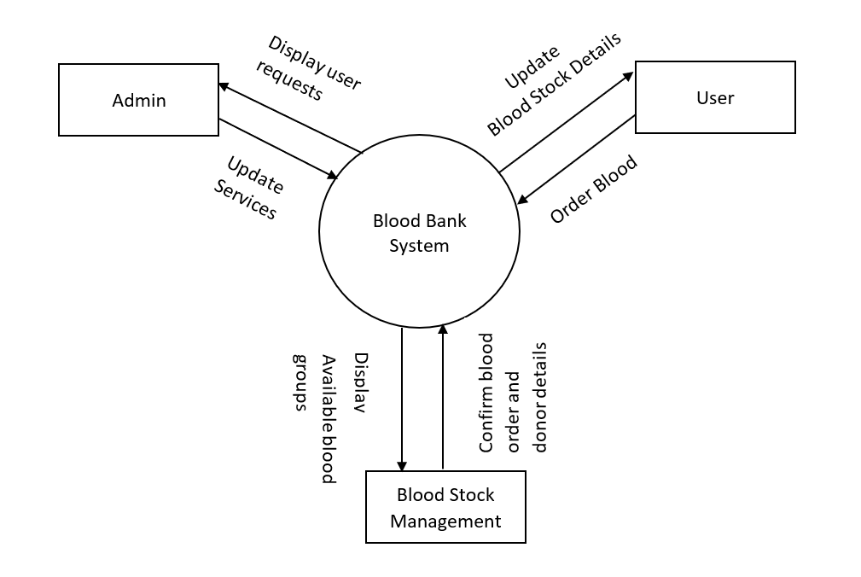

***2.3.2 Level 0 DFD:***

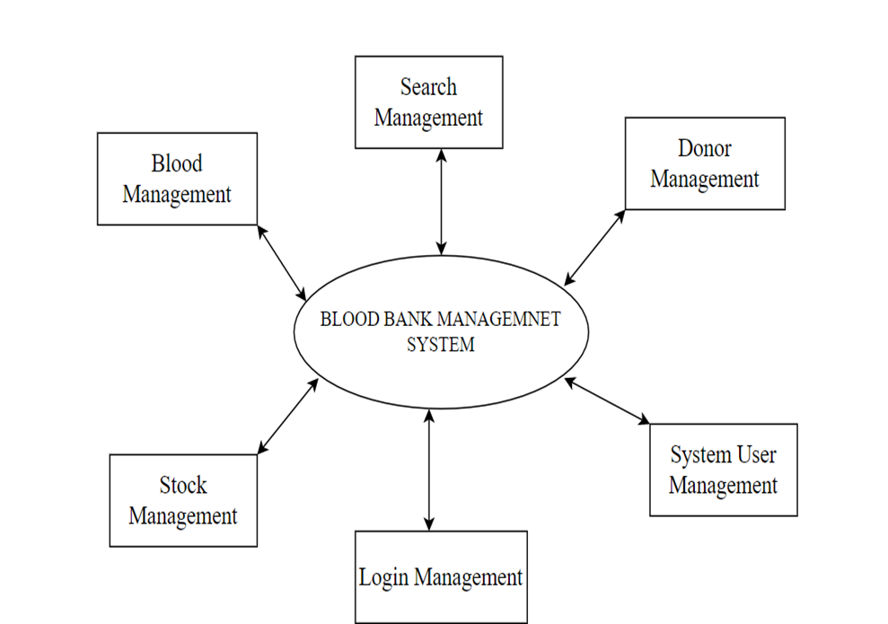

***2.3.3 Level 1 DFD:***

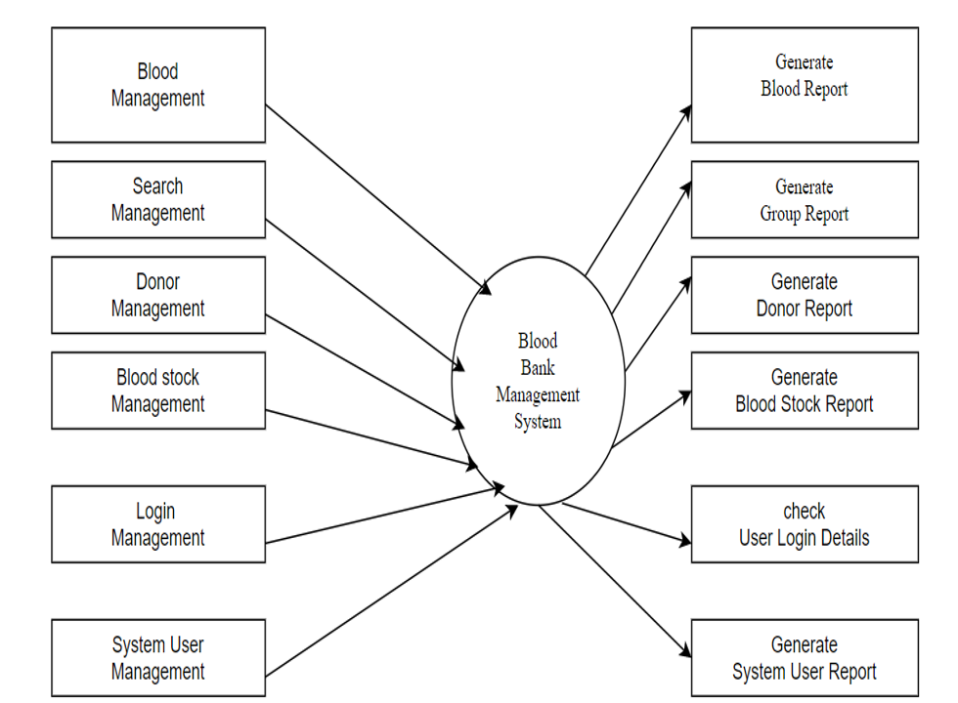

***2.4 Use Case Diagrams***

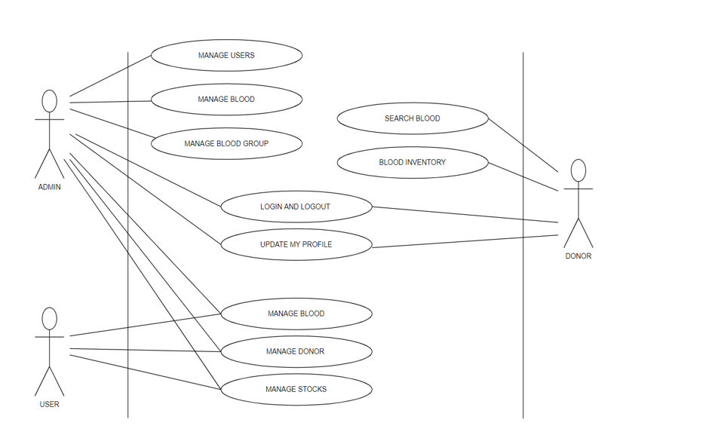

***2.5 User classes and characteristics:***

The users of this system will include the donor, staff, and administrator. The user classes for the system being developed have been broadly classified as follows.

* Donor
* Recipient
* Admin

***Login:***

The system provides security features through username-password.

***Input:*** Username, Password

***Output:*** Invalid or Update Blood Details, logout

***Donor Profile Registration:***

***Input:*** Donor/ Recipient Id, Name, Date of Birth, Sex, Blood Group, Address, Contact Number, Email Address, Diseases (if any), Aadhaar Card No.

***Output:*** Successfully Registered.

***Blood Stock Management:***

The blood bank staff can manage the bloodstock starting from the blood through the system. Each process or workflow can be traced from the database.

***EXIT:***

We can the menu called exit which directly exists the application and removes the application which means only the application goes to a home and when we press the exit application whole project ends.

**2.6 Operating environment**

The proposed software is to run on a client/server model network. A client/server can deliver better performance than the file system because a client application and database server work together to split the processing load of applications.

The operating environment is as follows:

* Database: MySQL
* Web server: HTTP server
* Google chrome

***2.7 Design/implementation constraints:***

* complicated to operate.
* Uses less RAM and processing power.
* The only person who can access the whole system is Manager.
* Database is password protected.
* Risk of computer virus.
* Online Systems require high-speed internet connectivity.

***2.8 Assumptions and dependencies:***

* Each user must have a valid user id and password.
* Users must log in to the system to access their status.
* Only the Manager/Receptionist can update records.
* GUI is only in English.
* Login and password is used for identification of the user and there is no facility for guest.
* The system should be user-friendly so that it is easy to use for the users to operate easily.

***3. External Interface Requirements***

***3.1 User Interface:***

The user interface for the system shall be compatible with any type of web browser such as Mozilla Firefox, Google Chrome, and Internet Explorer.

**3.2 Hardware Interfaces:**

There are various hardware components with which the machine is required to interact

* Operating system: Windows 7 (or above can be used) since it is stable.
* Hard disks: 40GB
* RAM: 1GB as it will give faster performance throughput.
* Hardware requirements for the Blood bank management system for the users should have a high-speed internet connection to deploy the project to the administrator

***3.3******Software Interfaces:***

The website will be a user interface with standard Windows API and GUI. Data that will be shared between computers and details regarding the patients required by the donors will be pulled from the patient database as needed/requested. This database can be configured and deployed for usage in case-specific usages for each hospital network that uses the software by using LAN or the internet. The database will be accessed through standard SQL scripts, which will be native to the system and included as packages. All the coding part can and GUI parts can be done in Eclipse or Net beans.

***Client End*:**

OS - Windows 7/8/8.1/10 - Very user-friendly and common OS

MySQL server - Database connectivity

***3.4 Communications protocols and Interfaces:***

* NIC (Network Interface Card) – It is a computer hardware component that allows a computer to connect to a network. NICs may be used for both wired and wireless connections.
* Windows operating system is needed for the basic communication interface.
* TCP/IP protocol- Internet service provider to access and share information over the Internet.

**4. System Features**

***4.1 Login Interface:***

The user should enter a valid username and password to get access to their profile.

***4.1.1 Description and priority:***

A login system is provided to the users.

Users include the donor, admin, and Recipient.

***4.1.2 Action/result:***

*The home/main page of the system is displayed after successful login.*

***4.1.3 Functional requirements:***

* The system asks the user to enter the username and password.
* User fill in the existing details of username and password.
* The details are validated by the system.
* If they are correct, the user can log in to the system
* If the details are not valid, an error user message is displayed by the system.

***4.2 Logout***

***4.2.1 Description and Priority:***

The user should be able to log out of the system.

Users include the donor, admin, and Recipient.

***Precondition:***

The user should be logged in to the system.

***4.2.2 Action/Result:***

The user logs out of the system and another user can log in.

***4.2.3 Functional Requirements:***

* The user clicks on the logout button.
* The system logs out from the current user’s profile

***4.3 Donor Profile***

***4.3.1 Description and Priority:***

The user will be able to see their Account Number, Blood Donation Receipts, Donation to the Bank, Blood Need to the Bank, and Blood Request.

***4.3.2 Action/Result:***

The user can edit or enter his personal details like name, email, ph.no, gender, d.o.b, blood group,aadhaar card no, and address

***4.3.3 Functional Requirements:***

* User selects the user details option
* System displays the user details
* User selects the update user details option
* System displays the existing user details

**4.4 Blood Stock Management**

***4.4.1 Description and Priority:***

If the donor is registered with the bank, it will display the Complete Donor Information or Account No. along with the Blood Details for that particular bottle.

***4.4.2 Action/Result:***

The user has access to information about blood donors as well as the amount of bloodstock that is currently stored in the bank. He can order specific blood from the bloodstock if he wants blood from a particular blood group.

***4.4.3 Functional Requirements:***

* The user chooses the blood group stock he wants
* System checks for the blood group from bloodstock
* System presents the amount of blood present in stock
* System presents the donor's details of the specific blood group
* Else, it displays no details are present.

***4.5* *Report:***

It will be available on the Admin’s Profile and will show the Availability of the Blood Groups with the no. of available bottles as per the admin’s choice to view the report as Month, Day, or Year.

***4.5.1 Validity Checks:***

To gain access to the system, the user is required to enter his/her correct user id and password and log in to his account. The user can access only one account at a time on one device. If the user is the information provider then the user has to enter the username and password to access and provide the information or to alter the donor's records or personal info.

***4.5.2 Error Handling/ Response to Abnormal Situations:***

If any of the above validation does not hold, appropriate error messages will be prompted the user for doing the needful.

***4.5.3 Sequencing Information:***

The information about the users and their records should be entered into the database and the backup will be maintained for all the user's/patient information.

***5.* *Other Non-functional Requirements***

***5.1 PERFORMANCE REQUIREMENTS:***

The following list provides a summary of the performance requirements for the software:

***5.1.1 CAPACITY:***

* The blood Bank management system provides service to customers 24/7 whenever users need it and wherever they are.

***5.1.2 DYNAMIC REQUIREMENTS:***

* Data in the database should be updated as soon as the user registers. Login Validation should be done within 3 seconds.
* The Blood Bank management system has to avoid degradation of its performance by processing one or at most two forms at a time.
* The load time of UI should not exceed more than 2 seconds.

***5.1.3 QUALITY:***

The primary objective is to produce quality software. As the quality of a piece of software is difficult to measure quantitatively, the following guidelines will be used when judging the quality of the software:

* Requirements Review
* Design Reviews
* Code Reviews
* Testing

***5.2 Safety Requirements:***

It is expected that the system, which would handle records in place of the manual approach over a long period, it is supposed to ensure the retaining of data avoiding or eliminating any probable cause for data loss.

***5.3 Security Requirements:***

The system should be secure no user is allowed to use it without proper authentication. Passwords should be hard and passwords should not be usernames as they are easy to be hacked. All external communications between the data server and the client must be encrypted. The database should be backed up every hour.

***5.4 Software Quality Attributes***

***5.4.1 RELIABILITY:***

The system should be reliable means there should not be any chance for the mistake or errors or bugs. The memory system shall be of non-volatile type

***5.4.2: Availability:***

The system is to be available as and when needed by the user at any time. The project should be made such that there are as less operating system dependencies as possible, or the software should be portable with only a few modifications.

***5.4.3 Maintainability:***

The system shall provide the capability to back up the database. The system should be flexible enough to add and handle new features. The system components i.e., modem, memory, disk, and drives shall be easily serviceable without requiring access to the vault. The system should be maintainable if any error has occurred then it should be easily rectified and the cost and time to solve it should be less.

***5.4.4 Usability:***

Software can be used again and again without distortion.

***5.4.5 Accessibility:***

The administrator and many other users can access the system but the access level is controlled for each user according to their workspace.

***5.5 User documentation:***

* The Administrator has the authority to fix the rules and regulations and to set or update the policies as and when required.
* The user should have an account to access the Blood Bank management system.
* Blocking or seizing of the account of the user on the discovery of any illegal activities.
* The user should immediately contact the support team if any fault has occurred in the system.
* Constantly monitor all the account information given by donors to check whether any one of them is encountering any fault.
* Immediately correct any fault discovered in any of the menu options.

***6. OTHER REQUIREMENTS***

***6.1 DEFINITIONS, ACRONYMS, ABBREVIATIONS:***

|  |  |
| --- | --- |
| ***SRS*** | ***Software Requirement Specification*** |
| ***AD*** | ***ADD Donor*** |
| ***FD*** | ***FIND DONOR*** |
| ***DD*** | ***DELETE DONOR*** |
| ***LA*** | ***LOCATION OF DONOR*** |

***6.2 To be determined:***

There should be a proper ups facility should be there in case of power supply failure because data base may be crashed anytime due to power failure. Laser Printer (B/W) - For printing details of stock availability made by the Person who is using the project There should be more quality and efficient server in order to make the process go in smoothly way in the peak hours.